PF LAB 2 ASSIGNMENT

Q2)

START

PRINT “Enter 3 different numbers”

INPUT num1

INPUT num2

INPUT num3

IF num1>num2 AND num1>3 THEN

PRINT “num1 is the largest number”

ELSE IF num2>num3 AND num2>num1 THEN

PRINT “num2 is the largest number”

ELSE

PRINT “num3 is the largest number”

END

Q3)

START

PRINT “ Enter 3 different numbers”

INPUT num1

INPUT num2

INPUT num3

SET sum to 0

sum = num1 (-)(-) num2 (-)(-) num3

PRINT “Sum of all numbers is: ” , sum

END

Q4)

START

SET sum to 0

PRINT “Enter two numbers”

INPUT num1

INPUT num2

PRINT “If you want to add the numbers enter ‘+’ otherwise enter ‘-‘”

INPUT operator

IF operator == ‘+’ THEN

sum = num1 + num2

PRINT “=” , sum

ELSE IF operator == ‘-‘ THEN

sum = num1 – num2

PRINT “=” ,sum

ELSE

PRINT “Error”

END

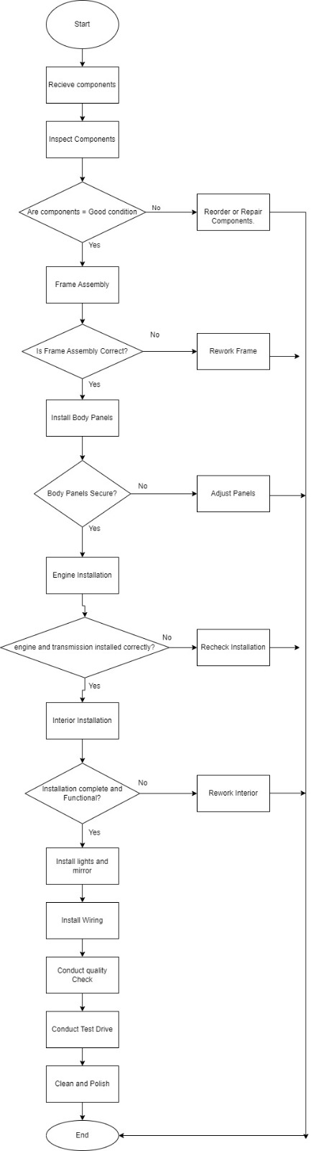Q5

Q6)

START

SET x = 1

PRINT (“Enter a number”)

INPUT num

FOR count x to num-1

IF num mod x == 0 THEN

PRINT (x, “is a divisor of” , num)

IF x mod 2 == 0 THEN

PRINT(x, “is an even number”)

ELSE

PRINT(x, “is an odd number”)

ELSE

PRINT (x, “is not a divisor of” , num)

x = x +1

ENDIF

END

Q7)

START

PRINT(“Enter a number”)

INPUT num

IF num == 1 THEN

PRINT (“January”)

ELSE IF num ==2 THEN

PRINT (“February”)

ELSE IF num == 3 THEN

PRINT (“March”)

ELSE IF num == 4 THEN

PRINT (“April”)  
 ELSE IF num ==5 THEN

PRINT (“May”)

ELSE IF num == 6 THEN

PRINT (“June”)

ELSE IF num == 7 THEN

PRINT (“July”)

ELSE IF num== 8 THEN

PRINT (“August”)

ELSE IF num == 9 THEN  
 PRINT (“September”)

ELSE IF num == 10 THEN

PRINT (“October”)

ELSE IF num == 11 THEN

PRINT (“November”)

ELSE IF num == 12 THEN

PRINT (“December”)

ELSE

PRINT (“Invalid entry”)

END

Q8)

START

ans = 0

PRINT(“Enter a number”)

INPUT num1

PRINT(“Press A for +, S for -, M for \*, D for /, R for %”)

INPUT op

PRINT(“Enter another number”

INPUT num2

IF ( op == ‘A’) THEN

ans = num1 + num2

ELSE IF (op == ‘S’) THEN

ans = num1 – num2

ELSE IF (op == ‘M’) THEN

ans = num1 \* num2

ELSE IF (op == ‘D’) THEN

ans = num1 / num2

ELSE IF (op == ‘R’) THEN

ans = num1 MOD num2

ELSE

PRINT(“Invalid entry”)

PRINT ans